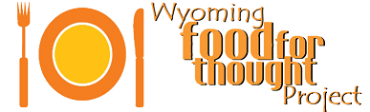­­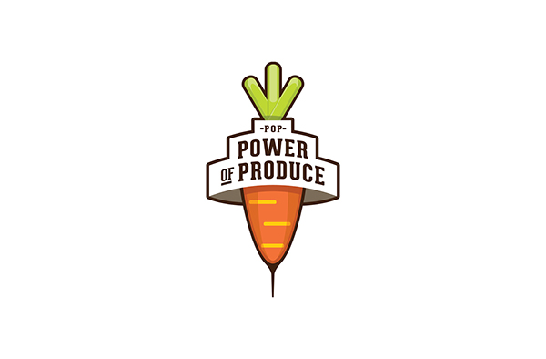

**FREE Activities**

**,**

**T**

**astings**

**and Pr**

**iz**

**es for Kids!**

J

oin us at the

POP Club tent

**H**

**E**

**Y**

**K**

**I**

**D**

**S**

**!**

Brought to your local farmers market in

partnership with

Food for Thought Markets

and the

Farmers Market Coalition



**Tuesday Nights June 21st – Sept 27th**

**On the grounds of the Nic, starting at 5:30pm!**

**Get $2 in POP Club Bucks to spend at the market!**

**The Food for Thought Summer Market takes place on the grounds of the Nicolaysen Museum every Tuesday night from 5:00-7:30pm (June 21st through September 27th).**